# NETWORK SECURITY USING PROXY SERVER

A COURSE PROJECT REPORT

By

**PIYUSH KUMAR (RA2011031010078)**

**PRERNA SHARMA (RA20110311010086)**

Under the guidance of   
**Dr. S. Thanga Revathi***In partial fulfilment for the Course*

of

18CSC302J - COMPUTER NETWORKS

in Department of Networking and Communications



**FACULTY OF ENGINEERING AND TECHNOLOGY SRM INSTITUTE OF SCIENCE AND TECHNOLOGY**

**Kattankulathur, Chengalpattu District**

NOVEMBER 2022

**SRM INSTITUTE OF SCIENCE AND TECHNOLOGY**

**(Under Section 3 of UGC Act, 1956)**

**BONAFIDE CERTIFICATE**

Certified that this mini project report "**Network Security using Proxy Server**" is the bonafide work of **Piyush Kumar (RA2011031010078)** and **Prerna Sharma (RA2011031010086)** who carried out the project work under my supervision.

# SIGNATURE

**Dr. S. Thanga Revathi**

# Assistant Professor

**Department of Networking and Communications**

**SRM Institute of Science and Technology**

# ACKNOWLEDGEMENT

We express our heartfelt thanks to our honorable **Vice Chancellor Dr. C. Muthamizhchelvan**, for being the beacon in all our endeavors.

We would like to express our warmth of gratitude to **Registrar Dr. S. Ponnusamy,** for his encouragement.

We express our profound gratitude to our **Dean (College of Engineering and Technology) Dr. T. V. Gopal,** for bringing out novelty in all executions.

We would like to express our heartfelt thanks to Chairperson, School of Computing, **Dr. Revathi Venkataraman,** for imparting confidence to complete our course project.

We are highly thankful to our Course project Faculty **Dr. S. Thanga Revathi, Assistant Professor, Department of NWC** for herassistance, timely suggestion and guidance throughout the duration of this course project.

We extend our gratitude to our **HoD NWC, Dr. Annapurani Panaiyappan** and Departmental colleagues for their Support.

Finally, we thank our parents and friends near and dear ones who directly and indirectly contributed to the successful completion of our project. Above all, we thank the almighty for showering his blessings on us to complete my Course project.

# ABSTRACT

With the growing reliance on connectivity to the World-Wide Web (Web), many organizations have been experiencing trouble servicing their users with adequate access and response time. Increase bandwidth on more connections to Web can relieve the access problem, but this approach may not decrease the access time. Additionally, increase bandwidth comes at greatly increased cost. Therefore, many organizations have turned to the use of proxy servers.

A proxy server is a Web server that caches Internet resources for re-use by a set of client machines and provides a gateway between users and the internet. Proxies provide a valuable layer of security for a computer. They can be set up as web filters or [firewall](https://www.fortinet.com/resources/cyberglossary/firewall-defined)s, protecting the computer from internet threats like [malware](https://www.fortinet.com/content/fortinet-com/en_us). This extra security is also valuable when coupled with a [secure web gateway](https://www.fortinet.com/products/secure-web-gateway) or other [email security](https://www.fortinet.com/products/email-security) products. This way, we can filter traffic according to its level of safety or how much traffic the network or individual computer can handle.

**TABLE OF CONTENTS**

## CHAPTERS CONTENTS PAGE NO.

**ABSTRACT**

* + - 1. **INTRODUCTION**
      2. **LITERATURE SURVEY**
      3. **REQUIREMENT ANALYSIS**
      4. **ARCHITECTURE & DESIGN**
      5. **IMPLEMENTATION**
      6. **RESULTS & DISCUSSION**
      7. **CONCLUSION & FUTURE ENHANCEMENT**
      8. **REFERENCES**

1. **INTRODUCTION**

Consider the situation where multiple users of an organization access the Web through the same server. Depending on the network’s Web connection, the increased number of requests can result in an overhead on main server. To overcome this issue, we introduce a proxy server which handles the requests on behalf of main server. Initially, when a user tries to access a certain Web page for the first time, registered within the domain of organization, the server refuses connection (it requires authentication). The server will forward, based on the URL, the request to the proxy server for authentication. Now, with the help of fast & reliable chat application, a secure listening port is assigned after validating the user’s credentials, stored in the organization’s database. The user is directed to a portal interface where this retrieved secured port is entered and after environment validation, the required Web page under the domain of organization is accessed by the user. If this series of actions is repeated over several to hundreds of users, the performance increase via reduced access time can a real benefit to the users on a network.

1. **LITERATURE SURVEY**

In the literature about information technology, the term “proxy” is also referred to as a “Stepping Stone”. Organizations that use Web proxy servers report that the proxy server’s caching technology has greatly reduced network costs. Many organizations bought proxy servers in order to decrease access time. However, they received an unexpected benefit when caching reduced traffic on the Internet connections. Industry analysts report that proxy servers often reduced traffic enough to eliminate the need to add bandwidth servers. The demand for proxy servers among businesses, organizations, government, and academic was been strong. Microsoft, Netscape and Novell all offer proxy-server software as part of their Internet server suites. The demand is understandable given the reported increases in performance from users. Reported performance enhancements from proxy server for end users is typically about 20 to 25%, i.e., a one-quarter decrease in access time. Organizations also reported high volume of proxy server cache access, as high as 40% and extremely active caches with thousands of Web documents.

Once the proxy server receives the request, it analyses the said request in order to determine the desired resource accompanied by its designated server or machine, as well as any additional information that it needs to relay, after which it connects and forwards the request to the target server and waits for a response. Upon receipt, it forwards the reply back to its end client.

With all the positive reports, it is no wonder that proxy servers are still an active area of research. Most of the research focuses on methods to increase the performance aspect of proxy servers as opposed to the filtering aspect of proxy servers.

1. **REQUIREMENTS** 
   1. **Requirement Analysis**

From the given scenario, we draw the following requirements:

1. Identifying and validating system environment according to database and number of requests from the users.

2. Users should be able to access http:// and .org web pages within the organization’s domain.

3. Users of organization should have access only to the public IP address of the server and not the private IP address.

4. The users in the organization should have authorized access to the server.

5. SCTP administrates the chat application between user (client) and server.

6. Features and configuration required on the hardware with explanation.

We need to configure a network design keeping the following requirements in mind.

* 1. **Hardware Requirement**

For proxy server, we draw the following requirements:

* **Operating System-** Microsoft Windows, Squid (free proxy server, runs on distributions of Linux such as Red Hat or Ubuntu).
* **Processor requirements-**

1. Four or more 3.3 GHz Intel Xeon class or higher processor cores with more than 8 GB RAM.
2. Windows Server 8 requires a 2GHz processor, 2GB of memory and 40GB of hard drive space.
3. Ubuntu server edition requires a 300MHz processor, 128MB of memory and 1GB of hard drive space.
4. **ARCHITECTURE AND DESIGN**
   1. **Chat Application Interface**

Without the user authentication, unauthorized use is not possible. In this proxy server, the new trend of authentication is implemented which very fast and reliable. The flow mechanism of this fast authentication design is presented in following figure.

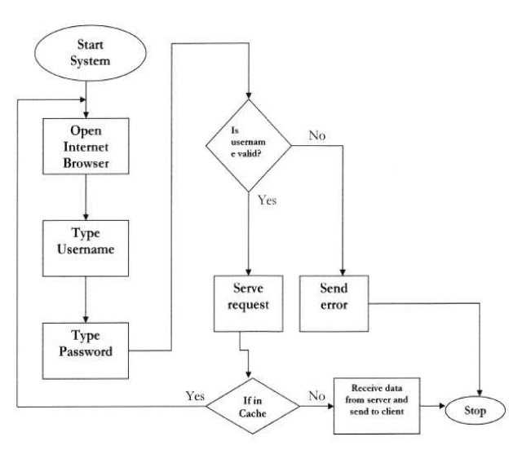

* 1. **Caching Mechanism**

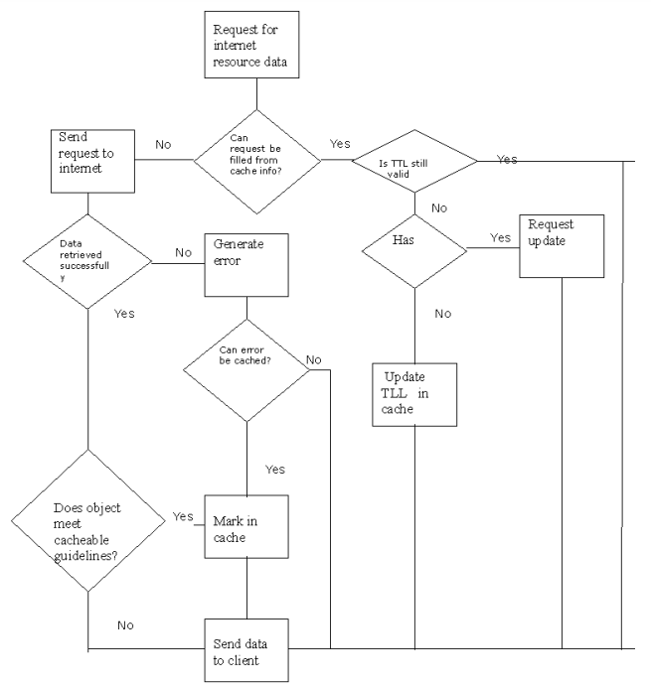

* 1. **Validation Architecture**

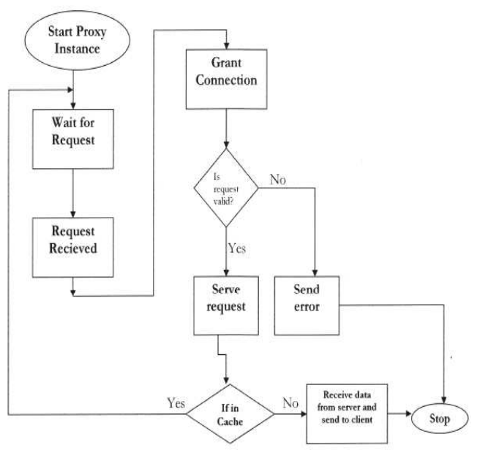

**4.4 Proxy Server Architecture**

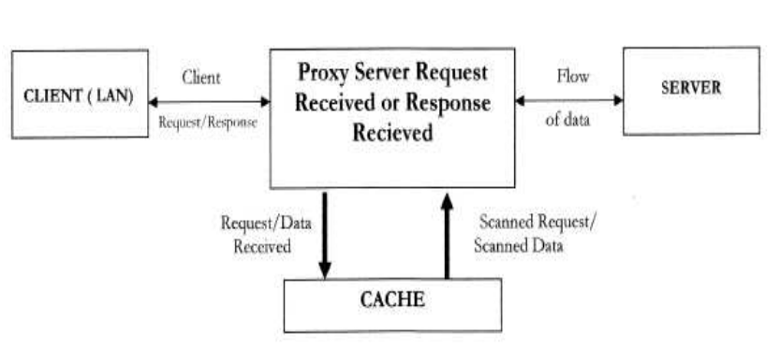

1. **IMPLEMENTATION**

A caching proxy server accelerates service requests by retrieving content saved from a previous request made by the same client or even other clients. Caching proxies keep local copies of frequently requested resources, allowing large organizations to significantly reduce their upstream bandwidth usage and cost, while significantly increasing performance. Most ISPs and large businesses have a caching proxy. These machines are built to deliver superb file system performance (often with RAID and journaling) and also contain hot-rodded versions of TCP. Caching proxies were the first kind of proxy server. The user requests for a web page within the domain of organization. Since, the user is not yet verified, the proxy server refuses to accept connection and demands authentication.

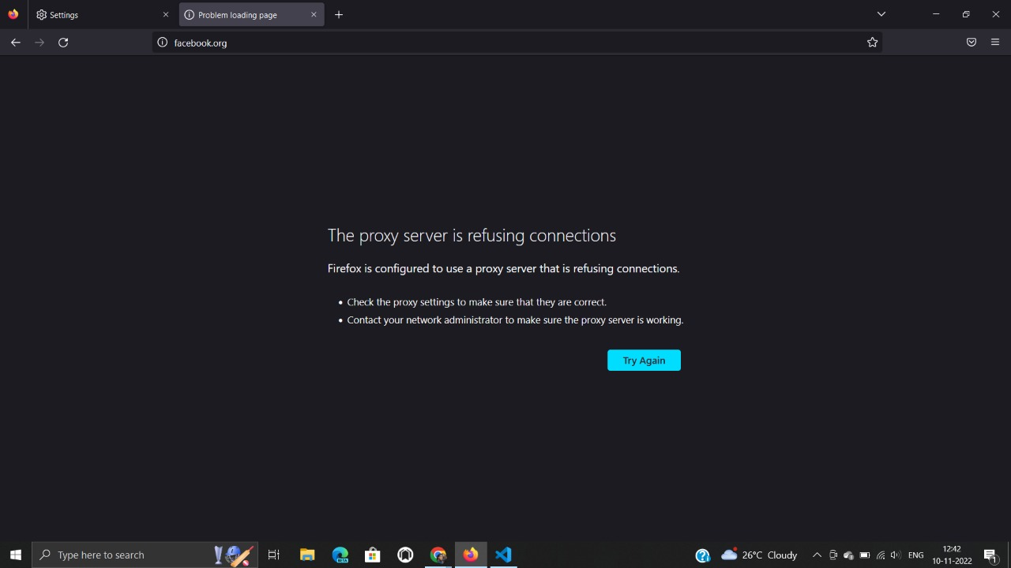

* 1. **Request for Secure Port**

A chat application is introduced for fast and reliable retrieval of secured listening port. The user (client) initiates the chat specifying his credentials while the server forwards the request to proxy server that validates (matching with the organization’s database records) and assigns the port.

**Server End:**

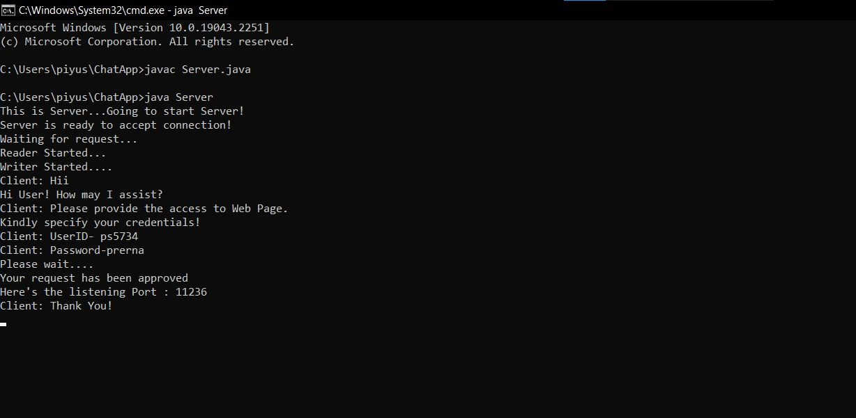

**User (Client End):**

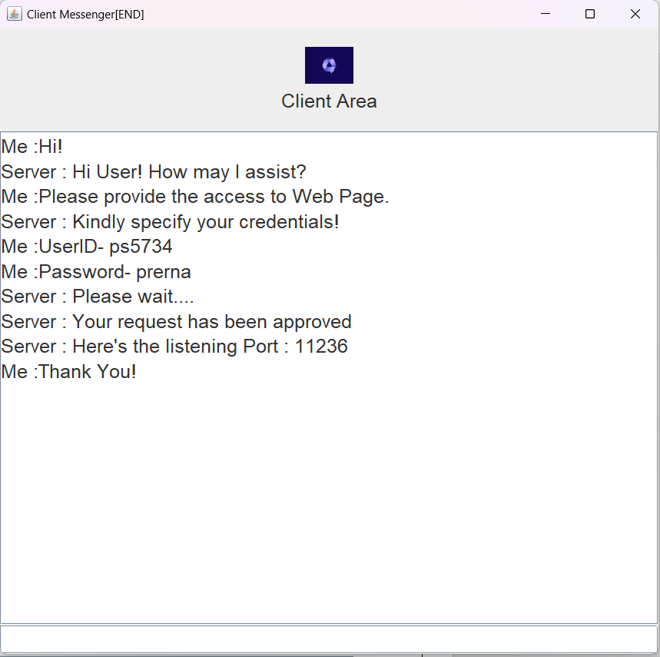

1. **RESULTS AND DISCUSSION**
   1. **User Authentication**

The proxy server validates the user according to the credentials stored in organization database.

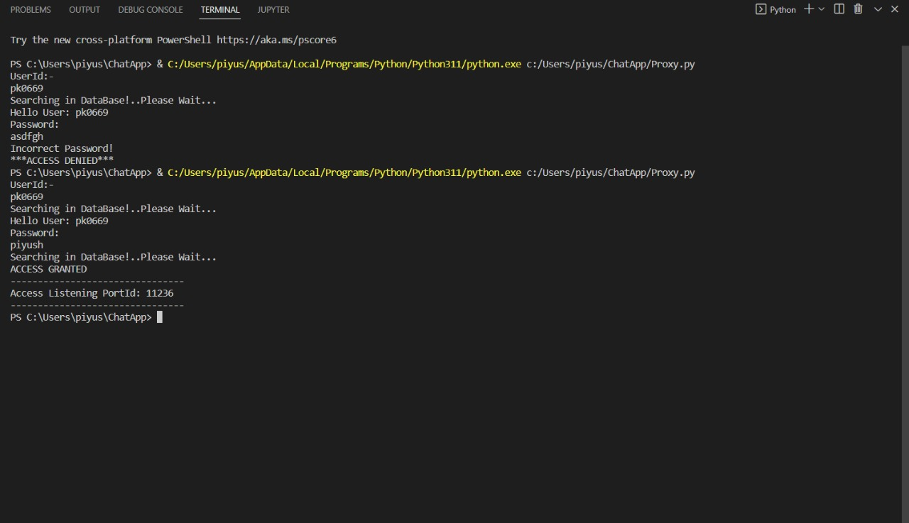

* 1. **Accessibility through Portal Interface**

The port is entered in the portal that analyzes and provide accessibility to the required web page.

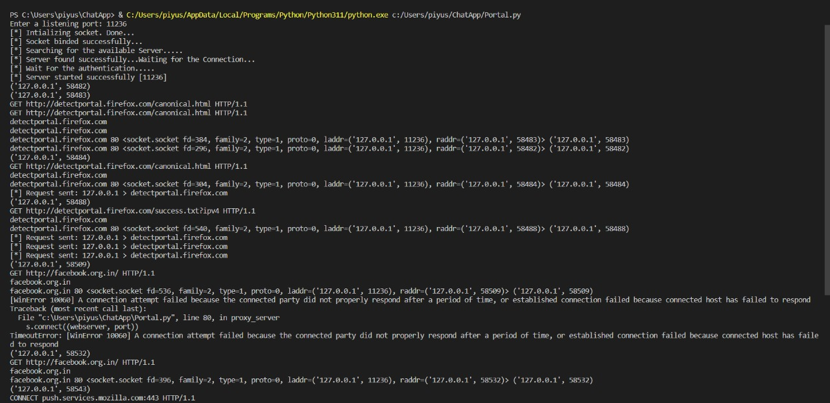

* 1. **Requested Web page accessed**

The user successfully accesses the required web page.

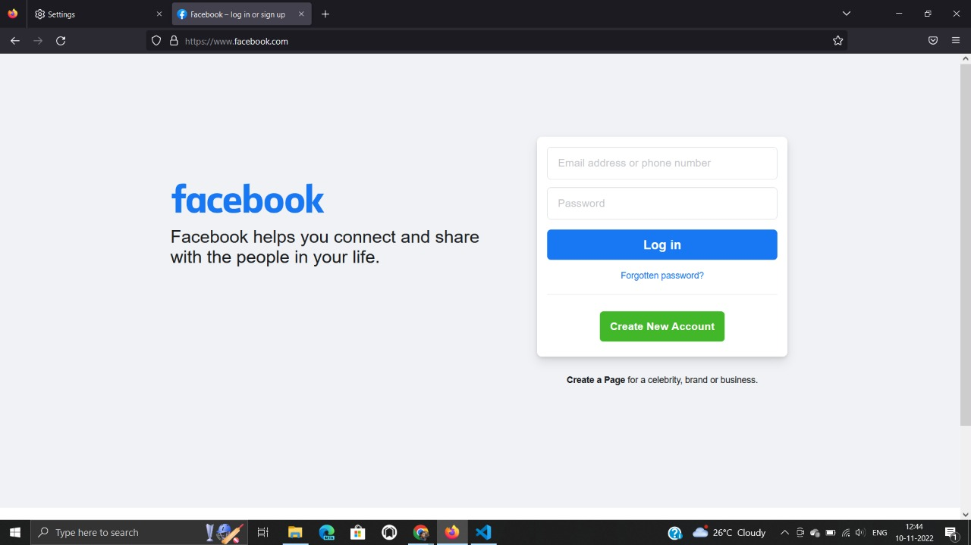

1. **CONCLUSION AND FUTURE ENHANCEMENT**

As we [march towards the phase of digital transformation](https://www.f5.com/company/blog/the-three-phases-of-digital-transformation), the collection and analysis of data from every point in the code-to-user application path is critical. Organizations rely heavily on data security and fast retrieval along with improving performance, create efficiencies and increase competitive advantage. At the same time, it is also critical to combat the advanced security threats companies face today and will continue to face in the future.

Early on, network packet-filtering appeared to win because of a focus on speeds and feeds. Packet-filtering approaches operate on individual packets, which in the past often made them faster than their connection-oriented proxy cousins. Security solutions built on packet-filtering approaches evolved into more stateful engines becoming ‘application-aware’, placing a greater focus on application and identity. Still, the core value proposition of packet-filtering based security relied heavily on the inspection of individual packets at speed.

Eventually, proxy servers evolved to provide value that eclipsed the early advantages of packet-filtering. The key to that value is two-fold: First, they provide visibility into every interaction – from user to application, from the network to the application, and across logical business flows, that all enable it to detect advanced attacks. And second, a programmable proxy can inject code, enrich headers, and insert trace data to dynamically instrument clients and applications. In other words, inspection was no longer enough –they provide the critical ability to instrument interactions with the breadth and depth of data needed to discover patterns and produce actionable security insights.

**REFERENCES**

* <https://www.researchgate.net/publication/304158964_Exploring_Proxy_Detection_Methodology>
* <https://faculty.ist.psu.edu/jjansen/academic/pubs/ic3n98/ic3n98.html>
* <https://www.fortinet.com/resources/cyberglossary/proxy-server>
* <https://cyberleninka.org/article/n/1043319>
* <http://ijcsit.com/docs/vol1issue2/ijcsit2010010212.pdf>